# Name Convention

1. 变量符号及含义

|  |  |
| --- | --- |
|  | 表示 |
| Dataset数据集 | 是samples（ features every sample）  是分类结果 (K classes in total) |
| Feature/Attribute特征 |  |
| Node |  |
| Directed Edge |  |

1. 常用词汇

* Decision Tree
* Node
* Internal Node: feature/property
* Leaf node: a class
* Directed edge

# 分类树概况

## 理解分类树

1. 逻辑角度上，decision tree是一组if-then规则的集合，if是feature层面的，then是分类结果层面的。
   1. Root node到leaf node的每一条路径都代表一种if规则，且路径上每一个内部节点都代表一种feature的if条件 # 决策树上的路径或者if规则集合满足特性：互斥且完备， 也就是说每个instance分类结果（then）都有且仅被一条规则（if）覆盖
   2. Leaf node代表then，是instance 分类的结果
2. 概率论上，decision tree是指特定条件下，类的条件概率分布。这一条件概率分布是定义在特征空间（feature space）上的一个划分（partition）， 被划分成一个个互不相交的单元（cell）或区域（region），并在每个cell/region定义概率分布就构成了条件概率分布。

## 分类树思维导图

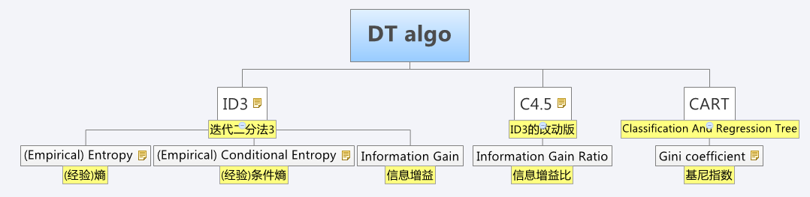

## 分类树步骤

1. Feature selection
2. Decision Tree Generation
3. Decision Tree Pruning

# 分类树算法

## ID3

### (Empirical) Entropy (经验)熵

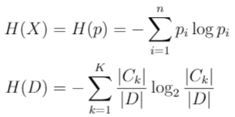

* 熵只与X的分布有关，与X取值无关
* empirical 一次表示 熵中的概率估计是直接用数据分布得到的，而不是原始概率分布函数，有一定的经验性

为什么熵能有效地判断一个特征的分类能力呢？用伯努力0/1二分类(抛硬币统计正反面)为例，



这时随p变化的曲线如下图：

* 当p=0.5, 熵最大，和实际情况一致，0，1完全随机分布，很难预测，预测准确全凭猜测就是一半一半。
* 当p<0.5时，熵变小，结果偏向0的概率大一些了
* 当p>0.5时，熵变小，结果偏向1的概率大一些了

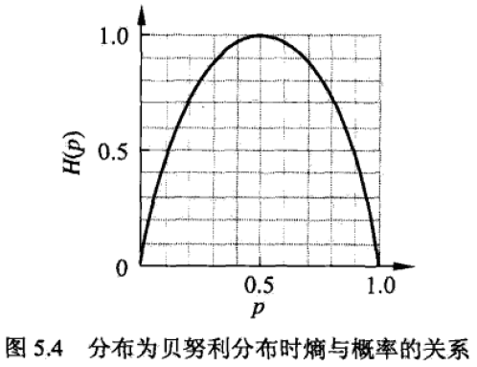

### (Empirical) Conditional Entropy (经验)条件熵

条件熵$H(Y|X)$表示在已知随机变量$X$的条件下随机变量$Y$的不确定性

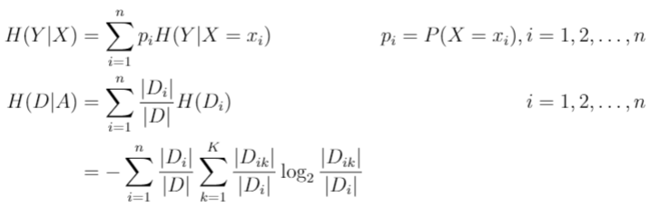

### Information Gain信息增益



### Pseudocode

ID3是一种贪婪的 启发式算法，其执行对局部最优熵值的局部优先搜索。每次都选择能使得当前root node 分类后熵最小的feature & partition，也就是信息增益最的feature & partition。

Samples/Dataset

Target Label/Class ,

Threshold

tree

ID3 (Samples/Dataset , Features , Threshold )

(0) Create output tree with an empty root node

(1) If all , then is single-node tree Root, return with label = .

(2) If number of predicting Features is empty(), then is single-node tree Root, return T

with label = most common value of the target label (label = ) in the samples.

(3) Otherwise Begin

Compute the information gain for all features in current Dataset

← The Attribute that best classifies examples(minimum Entropy / maximum info gain).

(4) If , return with label =

(5) Else

For each value of , Add a new tree branch below , get Dataset slice by

(6) subtree = ID3(Dataset, Features , Threshold )

End

Return Root tree

### Reference

1. <https://en.wikipedia.org/wiki/ID3_algorithm>
2. 统计学习方法

## C4.5

### Information Gain Ratio (normalized information gain)信息增益比(归一化信息增益)

之前“信息增益”概念，会更倾向于分类数多的特征，增加比值来归一化这个数。

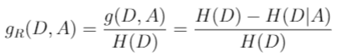

### Pseudocode of generating tree(discrete) C4.5树的生成伪码

C4.5 基本上只是对ID3的一种改进算法，criterion由信息增益改变为信息增益比

Samples/Dataset

Target Label/Class ,

Threshold

tree

C4.5 (Samples/Dataset , Features , Threshold )

(0) Create output tree with an empty root node

(1) If all , then is single-node tree Root, return with label = .

(2) If number of predicting Features is empty(), then is single-node tree Root, return T

with label = most common value of the target label (label = ) in the samples.

(3) Otherwise Begin

Compute the information gain for all features in current Dataset

← The Attribute that best classifies examples(maximum info gain ratio ).

(4) If , return with label =

(5) Else

For each value of , Add a new tree branch below , get Dataset slice by

(6) subtree = C4.5(Dataset, Features , Threshold )

End

Return Root tree

### Pseudocode of generating tree(continuous) C4.5树的生成伪码

<https://stackoverflow.com/questions/15629398/how-does-the-c4-5-algorithm-handle-continuous-data>

C4.5 (Samples/Dataset , Features , Threshold )

(0) Create output tree with an empty root node

(1) If all , then is single-node tree Root, return with label = .

(2) If number of predicting Features is empty(), then is single-node tree Root, return T

with label = most common value of the target label (label = ) in the samples.

(3) Otherwise Begin

Compute the information gain for all features in current Dataset

Sort Dataset in feature (continuous) in ascending order

Iteratively pick the threshold as (ai,j+ai,j+1)/2, and compute the info gain ratio

← The Attribute that best classifies examples(maximum info gain ratio ).

(4) If , return with label =

(5) Else

For each value of , Add a new tree branch below , get Dataset slice by

(6) subtree = C4.5(Dataset, Features , Threshold )

End

Return Root tree

### DT cost function 决策树整体代价函数

树 的叶结点个数为，是树的叶结点，该结点有 个样本点，其中 类的样本点有个，为叶结点上的经验熵，为参数，决策树学习的损失函数可以定义为:

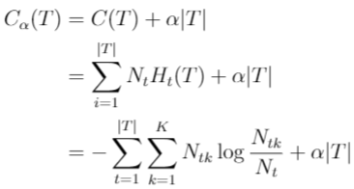

其中表示模型对训练数据的误差，表示模型复杂度，参数控制两者之间的影响。

### Pseudocode of pruning tree C4.5树的剪枝伪码

C4.5_Pruning (Tree , Parameter )

(0) Create output tree with an empty root node

(1) If all , then is single-node tree Root, return with label = .

(2) If number of predicting Features is empty(), then is single-node tree Root, return T

with label = most common value of the target label (label = ) in the samples.

(3) Otherwise Begin

Compute the information gain for all features in current Dataset

Sort Dataset in feature (continuous) in ascending order

Iteratively pick the threshold as (ai,j+ai,j+1)/2, and compute the info gain ratio

← The Attribute that best classifies examples(maximum info gain ratio ).

(4) If , return with label =

(5) Else

For each value of , Add a new tree branch below , get Dataset slice by

(6) subtree = C4.5(Dataset, Features , Threshold )

End

Return Root tree

## CART

CART(Classification And Regression Tree), 是一种广泛应用的决策树学习方法。

DT algo

ID3

(Empirical) Entropy

(Empirical) Conditional Entropy

Information Gain

C4.5

Information Gain Ratio

CART

Gini coefficient

C4.5

Information Gain Ratio

CART

Gini coefficient